Once upon a time, in the 19th century BCE, there was a king named Sin-kashid. He was not a very important king, but he ruled over an important city in southern Mesopotamia, the city of Uruk. There he rebuilt the temple, which was called Eanna, “House of Heaven,” and then he built his own palace. He labeled his palace from the inside, by having lots of little clay cones and tablets inscribed and embedded within its walls.
The text of these little cones and tablets says this: Sin-kashid, mighty man, king of Uruk, provider of the Eanna, when he built the Eanna, he built his royal palace.
Before the time of Sin-kashid, there was a king named Lipit-Ishtar who ruled the city of Isin, located upstream from Uruk along the Euphrates River. Lipit-Ishtar is known nowadays for issuing a law code, as the more famous King Hammurapi of Babylon did later. When he published his laws, Lipit-Ishtar also built Enisisa, the “House of Justice,” and he had its construction recorded on lots of clay cones like this one:
Seven Sages of Sumeria
Selz: Connects the Apkallu with the Fallen Angels
“The correspondance between Enmeduranki, for a long time considered to be the Mesopotamian Enoch, with an apkallū named Utu-abzu, proved highly informative.
(See W.G. Lambert, “Enmeduranki and Related Matters,” JCS 21 (1967): pp. 126-38; idem, “New Fragment.”)
Summary
via Apollodorus |  | via Abydenus |  | via Polyhistor
King | Fish-Man | King | Fish-Man | King | Fish-Man
Alorus |  | Alorus |  |  | An account of Oannes, and a claim he was followed by others similar
Alaparus |  | Alaparus
Amelon |  | Amillarus | [2nd Fish-Man]
Ammenon | Musarus Oannes | Ammenon
Maglarus |  | Megalarus
Daonus the Shepherd | [4th fish-man] | Daos the Shepherd | Euedocus, Eneugamus, Eneuboulus, and Anementus
Euedoreschus | Odacon | Euedoreschus | Anadophus
Amempsinus |  | [unnamed]
Otiartes |  | [unnamed] |  | Ardates
Xisuthrus | [deluge] | Sisithrus |  | Xisuthus
All acounts give ten kings, followed by a deluge

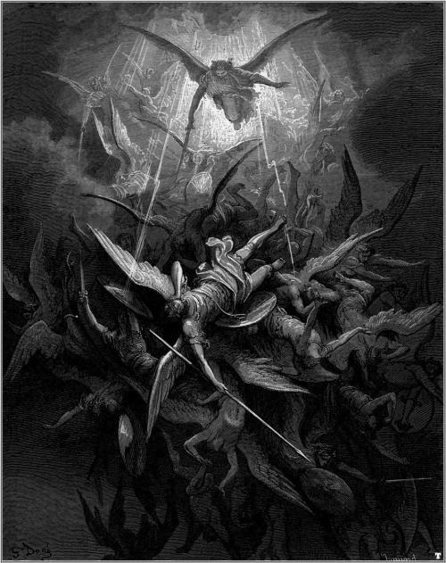
Paul Gustave Doré (1832-1883 CE), Michael Casts out all of the Fallen Angels, Illustration for Milton’s Paradise Lost, 1866.
This is a faithful photographic reproduction of a two-dimensional, public domain work of art. The work of art itself is in the public domain for the following reason:
This work is in the public domain in its country of origin and other countries and areas where the copyright term is the author’s life plus 100 years or less.
https://commons.wikimedia.org/wiki/Gustave_Doré
In 1974 Borger observed in an important article, that in tablet III of the omen series Bīt Mēseri (“House of Confinement”) a list of these apkallū is provided and that the apkallū Utu-abzu who is, as we have just seen, associated with the primeval ruler Enmeduranki is explicitly said to have “ascended to heaven.”
(“Beschwörung. U-anna, der die Pläne des Himmels und der Erde vollendet, U-anne-dugga, dem ein umfassender Verstand verliehen ist, Enmedugga, dem ein gutes Geschick beschieden ist, Enmegalamma, der in einem Hause geboren wurde, Enmebu-lugga, der auf einem Weidegrund aufwuchs, An-Enlilda, der Beschwörer der Stadt Eridu,” Utuabzu, der zum Himmel emporgestiegen ist, . . . ” (Borger, “Beschwörungsserie,” p. 192).
(“Summons. U -anna, completes the plans of the heavens and the earth, U-anne-dugga, accompanied by a comprehensive understanding, Enmedugga, who is granted good skill, Enmegalamma, who was born in a house, Enmebu-lugga, who grew up on a pasture, An-Enlilda, the Summoner of the city Eridu.”)
In Borger’s words we can therefore say: “The mythological conception of Enoch’s ascension to heaven derives . . . from Enmeduranki’s counselor, the seventh antediluvian sage, named Utuabzu!”
(Borger, “Incantation Series,” p. 232.)
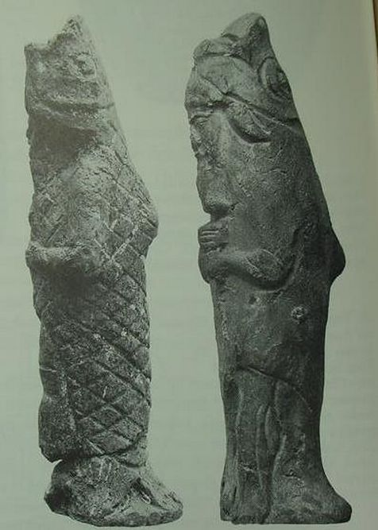
Purādu-fish apkallū were antediluvian sages, the famous Seven Sages of Sumeria were purādu-fish.
The genotype is also attested in Berossus, as the form of the mentor of mankind, Oannes.
The iconographic evidence for these apkallū is manifold and best known from various Assyrian reliefs. We usually refer to them as genii. Bīt Mēseri, however, describes them as purādu-fishes, and this coincides with iconographic research undertaken by Wiggerman some twenty years ago in his study on Mesopotamian Protective Spirits.
(F.A.M. Wiggermann, Mesopotamian Protective Spirits: The Ritual Texts (Cuneiform Monographs 1; Groningen: Styx, 1992).
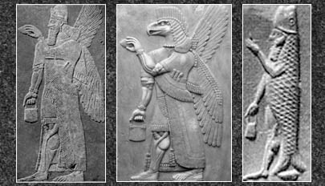
The three types of apkallū are portrayed, with the human ummânū at far left, the Nisroch bird-apkallū type in the middle, and the antediluvian purādu-fish type at far right.
The human ummânū is attested in the Uruk List of Kings and Sages, while other references to bird-apkallū are legion, as documented in Wiggermann and other authorities.
The purādu-fish apkallū is principally attested in Berossus, though other authorities confirm them, as well.
The anthropomorphic qualities of the purādu-fish and the Nisroch apkallū remain unexplained, though the eagle is sacred to Enki / Ea.
Wiggerman could distinguish between basically three types of genii, attested in the Mesopotamian art: First, there is a human faced genius, second, a bird apkallū who occur only in “Assyrian” contexts, and third, a fish apkallū, the original Babylonian apkallū, as described by Berossos; according to the texts the last two groups of apkallū are coming in groups of seven.
The first type, the human faced genius must be kept apart because these genii are depicted wearing a horned crown which explicitly marks them as divine.
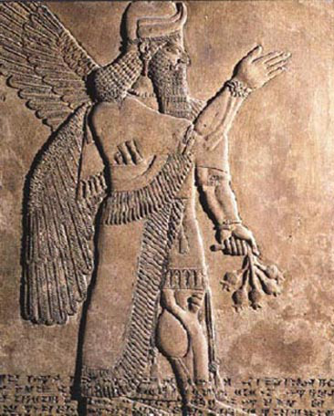
An ummânu, or sage of human descent. The ummânu raises his right hand in the iconic gesture of greeting, with what appear to be poppy bulbs in his left hand. Note the rosette design on his wristband, and the horned tiara headdress, indicative of divinity. Such human apkallū are invariably portrayed with wings, a further indicator of divinity or semi-divinity.
I cannot dwell here on the complicated issue of a possible intertextual relation between these apkallū and the “fallen angels” of the biblical tradition. Instead I will add some remarks concerning the following feature of the Enochic tradition, especially the Book of Giants.
1 Enoch 6:1-3 gives account of the siring of giants; men had multiplied and the watchers, the sons of heaven, saw their beautiful daughters and desired them.
Therefore, “they said to one another, ‘Come, let us choose for ourselves wives from the daughters of men, and let us beget children for ourselves.’
And Shemihazah, their chief, said to them, ‘I fear that you will not want to do this deed, and I alone shall be guilty of a great sin.’”
1 Enoch 7:1-2 describes that the women conceived from them and “bore to them great giants. And the giants begot Nephilim, and to the Nephilim were born . . . And they were growing in accordance with their greatness.”
Gebhard J. Selz, “Of Heroes and Sages–Considerations of the Early Mesopotamian Background of Some Enochic Traditions,” in Armin Lange, et al, The Dead Sea Scrolls in Context, v. 2, Brill, 2011, pp. 794-5.

Melvin: Divine or Semi-Divine Intermediaries
The Divine Source of Civilization in Mesopotamian Myths
“The motif of the divine origin of civilization is common in the ancient Near East, especially in Mesopotamia, and it stands in stark contrast to the portrayal of the rise of civilization in Genesis 1– 11.
(Although many of my observations with regard to the view of the rise of civilization presented in Mesopotamian mythology could also be made within the mythic traditions of other ancient cultures (e.g., Egypt, Greece, Canaan), Bernard Batto notes, “[f]or reasons not entirely clear to us the opening chapters of Genesis are typologically and content-wise more akin to the mythic traditions of Mesopotamia than of territorially closer Canaan—the reverse of the normal situation in the Hebrew Bible.”
(Bernard Batto, “Creation Theology in Genesis,” R. J. Clifford and J. J. Collins [eds.], Creation in the Biblical Traditions [CBQMS, 24; Washington, D.C.: The Catholic Biblical Association of America, 1992], 16).
For this reason, as well as the general consensus that the compilation of Genesis 1–11 occurred in the exilic or early post-exilic period, in large measure as a polemic against the Babylonian cosmological worldview in which the Jewish community found itself immersed, I have limited my comparisons of the biblical material to a number of Mesopotamian myths.)
In a number of mythological texts, civilization is portrayed as a gift bestowed upon humanity by the gods, and human advancement is generally a positive development. Often the arts of civilization come to humanity through divine or semi-divine intermediaries, such as the apkallus or heroes who are either semi-divine (e.g., Gilgamesh) or divinized humans (e.g., Lugalbanda, Utnapishtim).
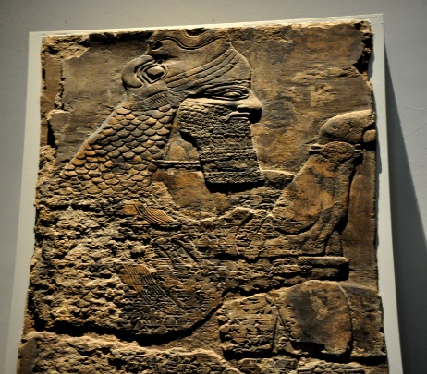
This depiction of a fish-apkallū of the purādu-fish type guarded the entrance to the temple of Ninurta at Nimrud.
A fish’s head can be seen on the Apkallu’s head, and its skin hangs down over the back of his body.
It is important to recall that the so-called Seven Sages of Sumeria were apkallū of this type.
Neo-Assyrian era, 865-860 BCE.
From the Temple of Ninurta, Nimrud (ancient Kalhu; Biblical Calah), northern Mesopotamia, Iraq. (The British Museum, London).
Osama Shukir Muhammed Amin FRCP (Glasg)
http://www.ancient.eu/image/2708/
According to the apkallu tradition, which comes to us from a wide array of sources ranging from the bilingual (Sumerian-Akkadian), “Etiological Myth of the Seven Sages” in the Bīt Mēseri 􏰀􏰁􏰂􏰃􏰄􏰅􏰆􏰇􏰈texts to the much later writings of Berossus (4th century BCE) and the Uruk Sage List (c. 165 BCE), as well as the Adapa myth and the epic myth􏰔􏰈􏰈􏰎􏰃􏰎􏰋􏰐􏰃􏰓􏰆 Erra and Ishum, semi-divine beings sent by Enki / Ea instructed antediluvian humans in the arts of civilization. The apkallus were teachers of early humanity whom Ea had endowed with “broad understanding” (uzna rapašta).
(Erica Reiner, “The Etiological Myth of the ‘Seven Sages,’” Orientalia 30 (1960), 4. See also Alan Lenzi, Secrecy and the Gods: Secret Knowledge in Ancient Mesopotamia and Biblical Israel (SAAS, 19; Helsinki: The Neo-Assyrian Text Corpus Project, 2008), 106–20. A similar description of the apkallus appears in the myth Erra and Ishum (COS 1.113:408).
(See the detailed description of the apkallus in Jean Bottéro, Mesopotamia: Writing, Reasoning, and the Gods (trans. Zainab Bahrani and Marc Van De Mieroop; Chicago: University of Chicago Press, 1992), 246–49. For a discussion of the Uruk Sage List, see Lenzi, Secrecy and the Gods, 106–09.)
(See Helge S. Kvanvig, Roots of Apocalyptic: The Mesopotamian Background of the Enoch Figure and the Son of Man (WMANT, 61; Neukirchen-Vluyn: Neukirchener Verlag), 295–318; Paul D. Hanson, “Rebellion in Heaven, Azazel, and Euhemeristic Heroes in 1 Enoch 6–11,” JBL 96 (1977), 226– 29.)
According to Berossus, they taught the people of Sumer “writing, science, and technology of all types, the foundation of cities, the building of temples, jurisprudence and geometry,” as well as such necessities as agriculture. In lists, they usually appear paired with the king whom they purportedly advised as a sort of vizier.”
David P. Melvin, “Divine Mediation and the Rise of Civilization in Mesopotamian Literature and in Genesis 1-11,” Journal of Hebrew Scriptures, 2010, pp. 3-4.
Share this:
- Twitter
- Facebook7
- Google
- Email
- Reddit

Like this:

Leave a comment
September 13, 2015
Izre’el: The Tale of the Adapa Myth
“Moreover, there is further textual evidence for the identification of the two figures in the combined name u-an(-na) adapa or u-ma-a-num a-da-pa (Lambert 1962: 73-4; van Dijk 1962: 44-8; Hallo 1963: 176; Bottéro 1969-70: 106; Borger 1974: 186; Picchioni 1981: 97-101; Kvanvig 1988: 202-4; Denning-Bolle 1992: 44-5; cf. Albright 1926).
The mythological figure Adapa has, thus, two variants: one is called Uan; another is called Adapa. The myth of the seven primordial sages shares with the Berossus tradition the mytheme of emergence from water. The etymological equation between Adapa and ù.tu.a.ab.ba is related to a similar tradition, while his having ascended to heaven is perhaps recalled by the name Uan, which includes a direct reference to heaven (An).

Purādu-fish apkallū were antediluvian sages, the famous Seven Sages of Sumeria were purādu-fish.
The genotype is also attested in Berossus, as the form of the mentor of mankind, Oannes.
Thus it was Oannes-Adapa who instructed people about the ordinance of the earth. It is with this theme that the myth of Adapa and the South Wind opens.
The Story
The myth as we know it opens with a description of the background to the main narrative. This background has reached us through what is now called Fragment A, of which the very first line or lines are missing (for the find and the extant fragments, see below).
The first legible lines refer to the power of divine speech, and it is said that Ea—known to us as the Mesopotamian god of fresh water and wisdom—perfected Adapa “with great intelligence, to give instruction about the ordinance of the earth. To him he gave wisdom, he did not give him eternal life” (lines 3’-4’).
Adapa was a servant of Ea. Respected and adored by his community, he performed the chores necessary to the daily rituals, which included, among others, supplying fish from the nearby sea.
One day Adapa’s journey to the wide sea ended unexpectedly in a sudden burst of the South Wind. Adapa was plunged into the sea. Here begins the narrative as we know it from Fragment B. This fragment has some close, albeit broken, parallels in Fragment C and at the beginning of Fragment D.
Adapa, who for the first time in his life had met with some difficulty, could do nothing other than to threaten the blowing wind that he would break its wing. As soon as he uttered this threat, the wing of the South Wind broke.
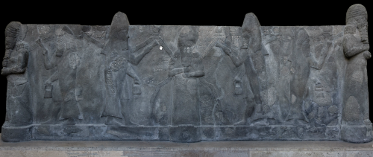
Click to zoom.
A solid basalt tub recovered from outside the Temple of Ishtar at Nineveh, now in the collection of the Pergamon Museum.
Ea is readily identified at the center with water flowing from his shoulders. Ea is surrounded by apkallu, puradu-fish apkallu.
The puradu-fish apkallu have a fish head and fish skin flowing down their backs. They raise rectangular objects of unknown etiology in their right hands, in their traditional acts of purification and blessing. The banduddu buckets are, as usual, in their lowered left hands.
This tub probably portrays the Seven Sages of antediluvian Sumeria.
Nothing could be done against Adapa’s spell, and Anu, the sky god and the head of the Mesopotamian pantheon, called Adapa to task. The situation was indeed unpleasant for the disciple of Ea. Yet, a god such as Ea would not risk a meeting between his loyal servant and Anu without proper preparation.
As might be appropriate for the god of wisdom, Ea, well known also for his artful character, supplied Adapa with minute instructions that were intended to save his life. Among these were strict orders to avoid any food or drink offered to him in heaven, any of which Ea said would bring death on Adapa.
However the situation turned out to be rather different from what Adapa anticipated. While in heaven, Anu’s anger was appeased by two deities, Dumuzi and Gizzida, who were standing at the gate of heaven. Following Ea’s instructions, Adapa had paid a tribute of flattering words to them. Instead of being offered deadly food and water, he was offered the food and water of life.
Adapa refused it, and thus—at least according to one recension, recorded in Fragment B—lost a unique and irreversible chance for eternal life.
However, according to another version of the story, recorded in Fragment D, Anu seems to have shown Adapa the awesomeness of heaven and to have installed Adapa in his own rather than in Ea’s service. This fragment also adds to the myth a healing incantation that is based on the very fact that Adapa, “a seed of humankind,” succeeded in breaking the wing of the South Wind.”
Schlomo Izre’el, Adapa and the South Wind: Language Has the Power of Life and Death, Eisenbrauns, 2001, pp. 2-5.
Dalley: Apkallu, IDD 2011
Iconography of Deities and Demons (IDD).
Apkallu.
“Mesopotamian semi-divine figure. A Babylonian tradition related by Berossos in the 3rd cent. (BURSTEIN 1978: 13f) describes a creature called Oannes that rose up out of the Red Sea in the first year of man’s history. His entire body was that of a fish, but he had another head, presumably human, and feet like a man as well as a fish tail.
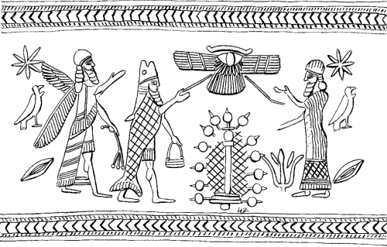
Apkallus type 1 and 2, Stephanie Dalley, IDD.
Two forms of Apkallu are depicted here, the umu-apkallu or ummanu on the left, holding what appears to be a branch with poppy bulbs, and the puradu-fish type with banduddu bucket in left hand.
The sacred tree appears at center, beneath a winged device whose meaning is unclear to me.
The figure on the right is probably a king, as the rich garment is not topped by a horned tiara, indicative of divinity.
He taught men to write, as well as many other arts, crafts, and institutions of civilization. He taught them to build cities and temples, to have laws, to till the land, and to harvest crops. At sunset he returned to the sea. Later there were other similar creatures who appeared on the earth. These were the sages.
The sage Adapa, a priest of Eridu created by the god Ea/Enki, was also called Oannes. The name Oannes was thus connected, by true or false etymology, with the common noun for a sage in early Akkadian ummiānum, later ummânum.
The other Akkadian term for a sage, apkallu, can also mean a type of priest or exorcist. According to a Sumerian temple hymn, the seven sages came from Eridu, the first city in the Sumerian King List. Since Eridu was the city of Ea who lived in the Apsu, iconography involving water and fish is to be expected for the sages. According to late Assyrian and Babylonian texts, legendary kings were credited early on with having sages.

This water basin carved from a solid block of basalt was found in Nineveh near the temple of Ishtar. It is decorated with reliefs of apkallu – puradu-fish antediluvian sages.
(Pergamon Museum, Berlin)
http://www.arcalog.com/image-library/museums/assyria/sennacherib/
The Epic of Erra and Ishum (probably 8th cent.) attributes to Marduk the banishing of the sages down to the Apsu, and not allowing them to return. He describes them as pure purādu-fish, perhaps carp, who like their master Ea are especially clever, and were put among mortals before their banishment.
The ritual text bīt mēseri, for encircling a house with protective magical figurines, gives names to the sages of some famous kings in various cities (REINER 1961; BORGER 1974; see also HUNGER 1983: nos. 8- 11). Some of those sages angered the gods.
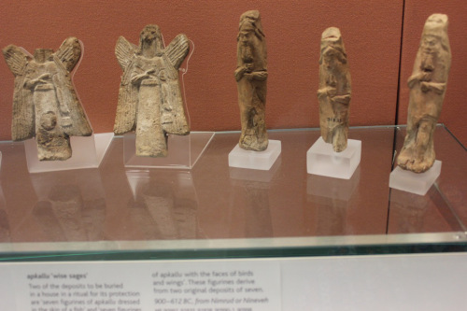
Bird Apkallū and Fish Apkallū, the so-called parādu-fish, side by side. Apkallū statuettes of this design were buried in appropriate places in the home of a Babylonian exorcist. They were believed to have apotropaic qualities, guarding the home from evil.
Ziusudra, also known as Utnapishtim and Atrahasis, was probably the last sage before the flood, the event which marks the division between immortal and mortal sages. Later sages were part mortal, part divine.
Kings credited with a sage include Enmerkar, Shulgi, Enlil-bani of Isin, Hammurabi, Nebuchadnezzar I, Sennacherib, and Esarhaddon, but this time span (legendary/Early Dynastic [26th cent.] to mid 7th cent.) does not match that of the identified iconography.
Certain texts are attributed to sages, notably two medical texts and a hymn (REINER 1961), the Myth of Etana, the Sumerian Tale of Three Ox-drivers, the Babylonian Theodicy, and the astrological series UD.SAR Anum Enlila.
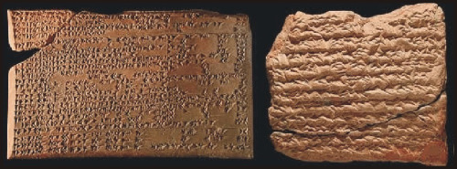
Enuma Anu Enlil is a series of about 70 tablets dealing with Babylonian astrology. These accounts were found in the early 19th century by excavation in Nineveh, near present day Bagdad. The bulk of the work is a substantial collection of omens, estimated to number between 6500 and 7000, which interpret a wide variety of celestial and atmospheric phenomena in terms relevant to the king and state. The tablets presumably date back to about 650 BC, but several of the omens may be as old as 1646 BC. Many of the reports found on the tablets represent ‘astrometeorological’ forecasts (Rasmussen 2010).
http://www.climate4you.com/ClimateAndHistory%205000-0%20BC.htm
In Assyrian tradition the sages guarded the Tablet of Destinies for the god Nabu, patron of scribes. This information gives a possible link with the composite monsters in the tradition of the Babylonian Epic of Creation, which centers on control of the Tablet of Destinies.
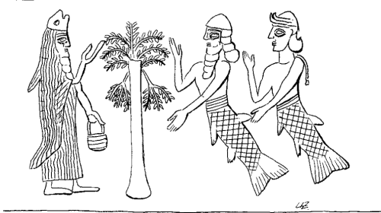
Apkallu type 2. Stephanie Dalley, IDD.
A puradu-fish apkallu appears to the left of the sacred tree, with two fish-men, apparently a merman and a mermaid, on the right.
Wiggermann identified these composite beings as kullilu.
Such a link would explain the scene that puts phenotype 1 (see § II.1) with composite monsters who fight as archers (24), and phenotype 2 (see § II.2) with mermen (44*, 51) and composite monsters (50*). However, in known versions of the Epic, the hero-god, not the composite monsters, is called a sage; thus the relationship is not clear.”
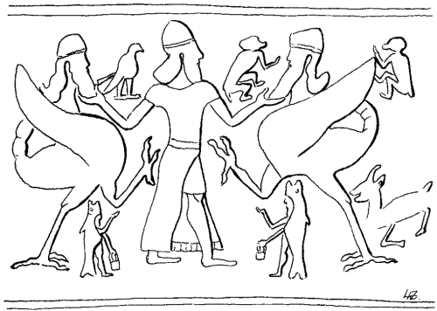
Wiggermann and Green call this composite being “Scorpion-tailed bird-man.” He has a human upper torso, an avian body, and a scorpion tail.
In this drawing from Dalley’s article on the Apkallu, puradu-fish apkallu can be seen beneath them (Dalley, figure 50).
Anthony Green, “Mischwesen. B,” Reallexikon der Assyriologie (RLA), 1994, pp. 254-5. figure 15.
Stephanie Dalley, “Apkallu,” Iconography of Deities and Demons in the Ancient Near East (IDD), Swiss National Science Foundation, University of Zurich, 2011 (text updated 2011 and illustrations updated 2007), p. 1/7.
Kvanvig: The Apkallus as Protective Spirits
“The apkallus are especially known from two incantation rituals: the one is Bīt Mēseri, as already stated; the other is called: šēp lemutti ina bit amēli parāsu, “to block the foot of evil into a man’s house” (KAR 298).
The two incantation series have a different scope. Bīt Mēseri prescribes the procedures to be performed when someone is ill, i.e. has come under demonic attack. Šēp Lemutti (“The Foot of Evil”) describes the procedures to be performed when a house should be protected from demonic attack. Consequently the rituals described have some common denominators, but also clear differences.
The rituals describe in great detail how figurines should be made of the seven apkallus. These figurines should then be addressed in an invocation to make them represent the apkallus themselves. In the case of Bīt Mēseri, where an ill person is concerned, the figurines should be arranged in the ill person’s room, close to his bed; in the case of Šēp Lemutti the figurines should be deposited in the foundation of the house.
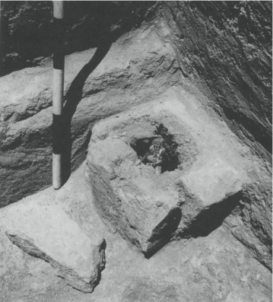
Apotropaic figurine deposit found in room S57 of Fort Shalmaneser at Nimrud. Adapted from Curtis and Read (1995:112). (From Nakamura).
We are here at a point where textual and archeological evidence support one another. An abundance of such small figurines are found in boxes buried in the foundations of houses and palaces from the Neo-Assyrian and the Neo-Babylonian period.
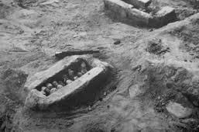
Nakamura: “By burying figurines of powerful beings, the āšipu preserves an expressed belief in a present reality of supernatural power, mythological origin and divine order.”
Because of the detailed description of their appearance in the rituals, it is not difficult to identify the excavated figurines as the same entities described in the rituals. The excavated figurines are representations of the seven apkallus.
(Cf. F.A.M. Wiggermann, “Mischwesen A,” Reallexikon der Assyriologie und Vorderasiatischen Archäologie (RLA) 8, Berlin, 1993-7, pp. 222-25, 222, 224.)
Moreover, having identified the small figurines, it is also possible to identify many of the large reliefs that flanked the entrances to the palaces of the Neo-Assyrian kings. Here the small figurines were blown up in large scale representations of figures with the same appearance as the small figurines, corresponding to the descriptions in the rituals.
(Cf. For a detailed examination of the evidence, Dieter Kolbe, Die Reliefprogramme religiös-mythologischen Characters in neu-assyrischen Palästen, EH, Reihe 38, Frankfurt am Main, 1981, III-VII, 14-30.)

The three types of apkallū are portrayed, with the human ummânū at far left, the Nisroc bird-apkallū type in the middle, and the antediluvian purādu-fish type at far right.
The human ummânū is attested in the Uruk List of Kings and Sages, while other references to bird-apkallū are legion, as documented in Wiggermann and other authorities.
The purādu-fish apkallū is principally attested in Berossus, though other authorities confirm them, as well.
The anthropomorphic qualities of the purādu-fish and the Nisroc apkallu remain unexplained, though the eagle is sacred to Enki / Ea.
There are three kinds of apkallus: fish-apkallus, bird-apkallus, and human apkallus. The fish-apkallu is represented as a fish-garbed figure, with a human body and a carp cloak (cf. the description in Berossos).
The bird-apkallu is represented as a griffin; he has a human body, wings and a bird’s head.
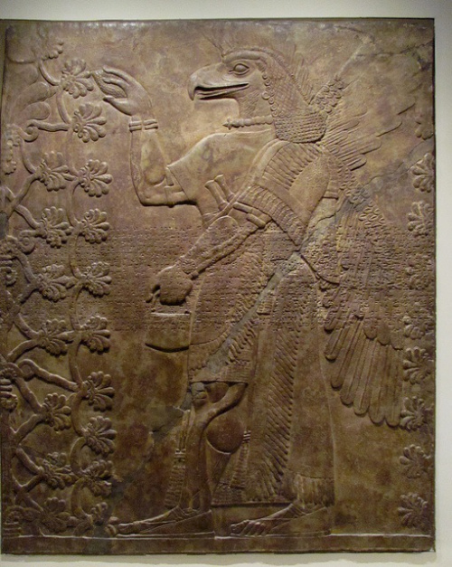
A bas relief in the Louvre.
In this case the bird-apkallū tends to a sacred tree. Considering the mullilu in his right hand and the banduddu in his left, (tree cone and water bucket), he is engaged in a water ritual intended to sanctify the sacred tree. This is a common motif in Sumerian and Neo-Assyrian idols.
This bas relief is in the Louvre.
Primary publication Nimrud NW Palace I-24 = RIMA 2.0.101.023, ex. 189 (f)
Collection Nimrud, Iraq (a); British Museum, London, UK (b); Louvre Museum, Paris, France (c); Nimrud, Iraq (d); Detroit Institute of Arts, Detroit, Michigan, USA (e); British Museum, London, UK; Louvre Museum, Paris, France
Museum no. Nimrud fragment no. 42 (a); BM 098061 (b); AO 22198 (c); Nimrud fragment no. 43 and 45 (d); DIA 47.181 (e) (photo: DIA); AO 19849
Accession no. 1903-10-10, 0002 (b)
Provenience Kalhu (mod. Nimrud)
Period Neo-Assyrian (ca. 911-612 BC)
(Cf. Anthony Green, “Mischwesen B,” Reallexikon der Assyriologie und Vorderasiatischen Archäologie (RLA) 8, Berlin, 1993-7, pp. 246-64, 252; Anthony Green, “Neo-Assyrian Apotropaic Figures,” Iraq 45, 1983, pp. 87-96.)
The representation of the human apkallu is more uncertain. A. Green suggests that these apkallus were imagined as genii, figures with human bodies and wings, holding a bucket in the one hand and a cone in the other.
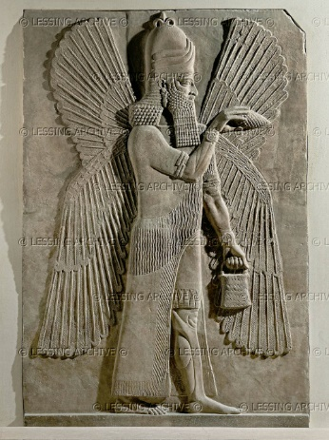
Now compare this Nimrud bas relief from the Louvre: an ummânū sprinkles water with a mullilu cone in his right hand, holding his banduddu bucket in his left.
This ummânū wears bracelets with a concentric circular design, and rosettes are not apparent.
This ummânū also wears the common horned headdress of Anu, but with three stacked layers of horns.
As noted elsewhere, this headdress is surmounted by an object that resembles a partial fleur de lis.
From Nimrud, capital of king Ashurnarzipal.
Louvre, AO 19845
Figures of fish-apkallus and bird-apkallus are found in Babylonian Ur and in several of the major Assyrian cities, Nimrud, Aššur and Nineveh. They are found in royal palaces and in houses assumed to belong to the guild of the āšipū, “exorcists.”

This depiction of a fish-apkallū of the purādu-fish type guarded the entrance to the temple of Ninurta at Nimrud.
A fish’s head can be seen on the Apkallu’s head, and its skin hangs down over the back of his body.
It is important to recall that the so-called Seven Sages of Sumeria were apkallū of this type.
Neo-Assyrian era, 865-860 BCE.
From the Temple of Ninurta, Nimrud (ancient Kalhu; Biblical Calah), northern Mesopotamia, Iraq. (The British Museum, London).
Osama Shukir Muhammed Amin FRCP (Glasg)
http://www.ancient.eu/image/2708/
(Cf. Dessa Rittig, Assyrisch-babylonische Kleinplastik magischer Bedeutung vom 13.-6. Jh. v. Chr., MVS. München, 1977, pp. 70-85, and pictures 20-31.)
The apkallus were, as stated, not only manufactured as prophylactic figurines. It is possible to find them in numerous examples of monumental art in Assyrian palaces. The fish-apkallu is also found in Persian Persagadae, placed at the entrance to the Audience Hall.
(Cf. Trudy S. Kawami, “A Possible Source for the Sculptures of the Audience Hall, Pasargadae,” Iran 10, 1972, pp. 146-8.)
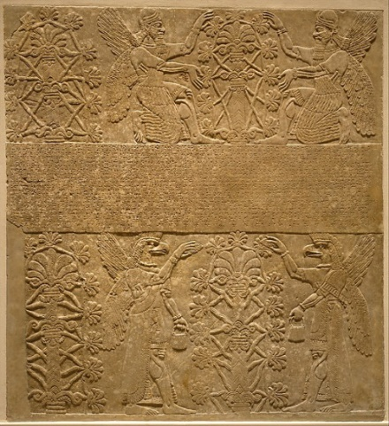
In this bas relief from Nimrud, human apkallū, the ummánū, kneel and tend to a sacred tree.
Both ummânū wear horned tiaras and display rosette bracelets on their wrists. Bracelets are also apparent on their upper arms.
In the lower register, bird-apkallū raise mulillu cones to sprinkle water in a gesture of exorcism and liberation of sin.
As is typical, the banduddu buckets are in their left hands.
Interestingly in this case, the bracelets of the bird-apkallū are atypical. No rosettes are apparent.
In the Assyrian palaces the apkallus are guarding the sacred tree, the king, and deities. Thus the apkallus were not only invisible present in rituals (sic); they were manufactured as figures and represented in impressive monumental art.”
Helge Kvanvig, Primeval History: Babylonian, Biblical, and Enochic: An Intertextual Reading, Brill, 2011, pp. 129-31.
Kvanvig: On the Destiny of Adapa
“The problem in the fragments to the Adapa Myth is that there is one crucial place where Amarna fragment B and the Nineveh fragment D overlap and they are significantly different. The last visible part of fragment B reads as follows, according to Izre’el’s translation:
“Come Adapa, why did you not eat and drink? Hence
you shall not live! Alas for inferior humanity!” “Ea my lord
told me: “Do not eat, do not dr[i]nk!”
“Take him (?) and [retu]rn him to (his) earth.”
(Amarna fragment B, rev. 67-70. Schlomo Izre’el, Adapa and the South Wind: Language Has the Power of Life and Death, Eisenbrauns, 2001, p. 21).
In the crucial last sentence here, we must admit that the only clearly visible signs are ana qaqqarišu, “to the,” or “his, earth.” Together with the traces left of verbs they nevertheless show the destination: Adapa is returning to the earth. As we shall see below, the outcome in exactly the same scene in fragment D is the opposite: Adapa will remain in heaven as the chosen of Anu.
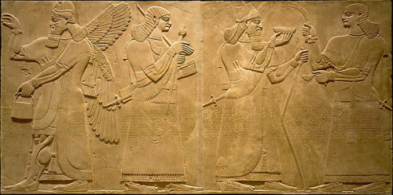
The umu-apkallū at far left has his right hand raised in the iconic gesture of purification and exorcism, but no mullilu cone appears to be present.
The banduddû bucket is present in the left hand. This umu-apkallū wears a horned tiara, indicative of divinity.
The next entity lacks wings, and so is probably not an umu-apkallū. The mace in the right hand could be an e’ru, as it is not yet clear precisely what e’ru means. I do not understand the object in his left hand. The mace could be an indicator of sovereignty, of kingship.
The next entity holds a bowl and the curved staff, known as the gamlu-curved staff. While this entity wears a headdress, it is not horned, and wings are absent, suggesting that it is human rather than umu-apkallū. This is probably a king, Museum notes suggest Ashurnasirpal.
The entity at far right wields a curved stick in his right hand, I am unsure how Wiggermann defines it, and I am completely stumped by the object in his left hand, which appears to be a ladle. The entity appears to be a priest, blessing an offering from the king in a bowl.
Overall, this frieze supports one theme of Erica Reiner’s article on the Seven Sages of Sumeria, which is that each king had his associated advisor in the form of an apkallū.
If we do not read the myths according to their deepest structures, synchronically, but according to their plots on a narrative level, the difference between the older preserved variant of the story, fragment B, and the younger preserved variant, fragment D, cannot be overlooked.
To safeguard the argument, if the version of the scene in fragment D in the future should be found in an older tablet, the version would still be different from fragment B. In reading plots in narratives the beginning and end of the narrative are crucial.
Here we approach a problem in the Adapa myth; we do not have the exact beginning and the end of the story in any of the fragments, and we do not know exactly how they relate to one another, so we must make assumptions.
If we presume that the order of the fragments is rightly put together, there seems to be a scholarly agreement at this point; we are close to a beginning in fragment A, starting in line 2:
“Let (?) his [s]peech be (?) … […] like the speech of [Anu.]
He perfected him with great intelligence, to give instruction about the ordinance of the earth.
To him he gave wisdom, he did not give him eternal life.
In those days, in those years, the sage, a native of Eridu,
Ea made him (his) follower among people.”
(Nineveh fragment A obv. i, 2-6. Schlomo Izre’el, Adapa and the South Wind: Language Has the Power of Life and Death, Eisenbrauns, 2001, p. 10).
Here the basic themes that continue in the other fragments are introduced: the power of speech that made Adapa capable of breaking the South Wind’s wing, and changing the order of nature; the question about what kind of wisdom Adapa got from Ea, since only “the earth” and not the all-encompassing “heaven and earth” is mentioned; and the relationship between wisdom and eternal life. The rest of the fragments, including D, follow the story line fairly smoothly in relation to this beginning.
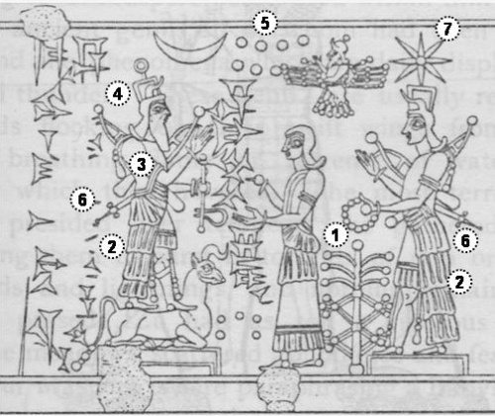
This illustration is cited as appearing as Figure 446 in “Cook (1964 Vol. 1 p.576-7),” which I take to refer to Cook H. J., “Pekah,” Vetus Testamentum 14 1964, figure 446, “Ramman the Bellowing One,” pp. 576-7. I have not been able to locate a copy to verify the reference.
This illustration allegedly portrays Ramman, “The Bellowing One,”or Adad, who is “commonly represented on the cylinders as standing on the back of a bull (Figure 446) or as planting one foot on a bull.”
I am not certain that the deity is standing on a bull at all. It could be Mushshushu, a dog-shaped dragon from Mesopotamian legend.
To my eye, this illustration portrays the Moon God, Sin, whose inverted crescent appears above his head.
The Assyrian national god Ashur appears in his winged conveyance, next to the seven celestial bodies of Babylonian cosmogony.
The goddess Ishtar appears at far right, her eight-pointed star at her head, and her typical warlike regalia on her back. Before her is a sacred tree. I do not know who the figure at the center of this illustration portrays.
We do not come so close to an end in either fragments B or D, because they are broken. In both places, however, we have a statement of the destiny of Adapa. In B this was to return to the earth, as we have seen; the last sentences in D concerning Adapa’s fate read as follows:
[An]u se[t] a decree to make glorious his lordship forever:
[ … ] Adapa, seed of humankind,
[ … ] he who broke the South Wind’s wing triumphantly
(and) ascended to heaven, —so be it forever!
(Nineveh fragment D rev. 11-14. Schlomo Izre’el, Adapa and the South Wind: Language Has the Power of Life and Death, Eisenbrauns, 2001, p. 38).
The end of a story matters. What takes place in a story moves between its beginning and end. If you change the end, you change the plot, even though the beginning and the events after the beginning are the same in a similar story.
Both the beginning and the succeeding events get another meaning when the end is totally different. In the fragment B the destiny was the return to the earth, which implies a dividing line between Adapa’s wisdom and eternal life, whatever structural level in the myth we place it in.
Adapa did not surpass the realm of the human getting eternal life, even with his extensive wisdom, and even though he became the patron of the magicians. Certainly, this has a meaning in relation to expelling demons, not only gods were able to do this; the power was given to humans, following the wisdom of Adapa.
The meaning of the destiny in D changes the plot. The focus is the elevation of Adapa as the one among humans who stayed in heaven with Anu forever.”
Helge Kvanvig, Primeval History: Babylonian, Biblical, and Enochic: An Intertextual Reading, Brill, 2011, pp. 121-3.
Share this:
- Twitter
- Facebook2
- Google
- Email
- Reddit

Like this:

Leave a comment
August 15, 2015
Kvanvig: The Apkallus had a Cosmic Function
“There is a clear difference between the group of seven and the subsequent group of four figures in Bīt Mēseri. The difference is not expressed in the same way as in the Uruk tablet in a general pattern of apkallus and succeeding ummanus. In Bīt Mēseri all the figures are apkallus with a curious exception of the last one, who is only two-thirds apkallu.
In Bīt Mēseri, there are thus two periods of transition, from the seven apkallus of divine descent to the four apkallus of human descent, and from the extraordinary apkallus to ordinary scholarship (we assume ummanus).

This depiction of a fish-apkallū of the parādu-fish type guarded the entrance to the temple of Ninurta at Nimrud.
A fish’s head can be seen on the Apkallu’s head, and its skin hangs down over the back of his body.
It is important to recall that the so-called Seven Sages of Sumeria were apkallū of this type.
Neo-Assyrian era, 865-860 BCE.
From the Temple of Ninurta, Nimrud (ancient Kalhu; Biblical Calah), northern Mesopotamia, Iraq. (The British Museum, London).
Osama Shukir Muhammed Amin FRCP (Glasg)
http://www.ancient.eu/image/2708/
The last transition is exemplified with Lu-Nanna; he is a mixture of both apkallu and, we must assume, ummanu. The difference between the first two groups is expressed through their origin. At the end of the list of four it is stated: [seb]et apkallu ša Ea bēlum [u]zna rapašta ušaklilušunuti,” of human descent, whom the lord Ea has endowed with a broad understanding” (lines 30-31).
“Born in the river” means engendered in the abode of Ea, which shows divine descent, in opposition to the human descent of the four succeeding ones, who, nevertheless are given great wisdom.
The apkallus are given a cosmic function. This is repeated twice, first in connection with the first apkallu, then in connection with all seven apkallus at the end of the list in Bīt Mēseri.
In both cases their responsibility concerns usurāt šamê u erseti (lines 1 and 13). Akkadian usurtu means concretely, “drawing,” abstractly, “plan, regulation, destiny;” so the apkallus are in charge of the “plans of heaven and earth.”
We have met this concept in Atrahasis where the birth-goddess Nintu: usurāti ša niši ussar, “draws the drawings for the people,” (S, 14), i.e. creates the basic conditions and fixes the destinies.
(Text in Lambert and Millard, Atra-Hasis, 62-3).
There is, however, a difference in Bīt Mēseri, which is made clear by the two different verbs used. In the case of the first apkallu (line 1) the verb mušaklil, participle, of the verb šuklulu (Š stem), is used. The verb means both “complete” and “make perfectly.”

In this bas relief from Nimrud, human apkallū, the ummánū, kneel and tend to a sacred tree.
Both ummânū wear horned tiaras and display rosette bracelets on their wrists. Bracelets are also apparent on their upper arms.
In the lower register, bird-apkallū raise mulillu cones to sprinkle water in a gesture of exorcism and liberation of sin.
As is typical, the banduddu buckets are in their left hands.
Interestingly in this case, the bracelets of the bird-apkallū are atypical. No rosettes are apparent.
The first apkallu thus “completed” or “made perfectly the drawings of heaven and earth.”
In the summary about all the apkallus (line 13) the verb muštešer, participle, Št stem, of the verb ešēru is used, which has the meaning “keep in order.”
Thus there is a distinction between what the first apkallu initially did, and what all apkallus did together. The first apkallu completed the design of the world-order; the seven apkallus, as a group, maintained this world order.
The corresponding Sumerian line 12 (the tablet is bilingual) has a text close to what we find in a Sumerian hymn. We quote the text in the German translation by van Dijk:
“Die urformen von Himmel und Erde
in rechter Ordnung zu halten, in die Weite von Himmel und Erde
den grossen Entscheidungen den Weg zu bahnen,
die Kultordnungen vollkommen zu machen.”
(Hymn to Nusku I, 14).
(J. van Dijk, Summarische Götterlieder, AHAW, PH, abh. I. Heidelberg 1960, 14; transliteration, 108; translation, 111.).
What is said here about the god Nusku is in Bīt Mēseri said about the apkallus. It covers the wide aspects of culture and civilization listed by Berossos about the first and seventh apkallu; it brings us, however, even one step further. The apkallus had a cosmic function; they were cosmic guardians.
They were both in charge of the me, and they were in charge of people’s destinies. In the last role, they are also described in a Babylonian myth where they are the custodians of the tablets of destinies.”
(W.G. Lambert, “The Twenty-One “poultices,”” AnSt 30 (1980): 77-83; B.R. Foster, “Wisdom and the Gods in Ancient Mesopotamia,” Orientalia (NS) 43 (1974): 344-54.).
Helge Kvanvig, Primeval History: Babylonian, Biblical, and Enochic: An Intertextual Reading, Brill, 2011, pp. 116-7.
Share this:
- Twitter
- Facebook2
- Google
- Email
- Reddit

Like this:

Leave a comment
August 5, 2015
Lenzi: Authority Rooted in Divinity
“As for the political aspect of the agenda, there are at least three points that require attention. First, we know that the locus of scholarship had shifted from court to temple, thereby removing (as far as we can tell) scholars from regular influence within the centers of political power.
(See, e.g., Francesca Rochberg, “The Cultural Locus of Astronomy in Late Babylonia,” in Die Rolle der Astronomie in den Kulturen Mesopotamiens: Beiträge zum 3 Grazer Morgenländischen Symposium (23-27 September 1991), ed. Hannes D. Galter, Grazer Morgenländische Studien 3 (Graz: Graz, 1993), 31-45, here 44.)
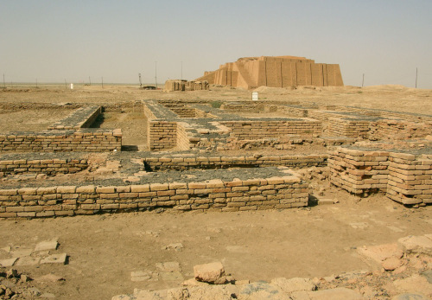
Ruins of Ur
http://www.ancient.eu/sumer/
Invoking the association of scholarship with memorable kings and their mythical sages or famous human scholars in the ULKS attributes to the Seleucid-era scholarly professions a venerable history, which in turn implies the scholars deserved a higher level of political influence or support than in fact they were enjoying at the time (see also the discussion of line 21 below).
Second, by emphasizing their historical connection to the antediluvian sages—the agents of Ea—the scholars were granting themselves authority rooted in divinity, a particularly difficult kind of authority to dispute.
Less systematic formulations of this genealogical idea in earlier materials provide us with the evidence to see that these Seleucid-era scribes were not inventing something new. Rather, their systematic and explicit formulation demonstrates their concern to make their position well-understood.
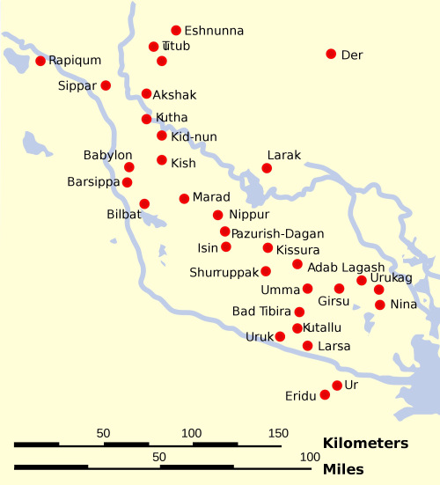
Map of the Main Cities of Sumer and Elam
Based on Wikipedia content that has been reviewed, edited, and republished. Original image by Phirosiberia. Uploaded by Jan van der Crabben, published on 26 April 2012 under the following license:
Creative Commons: Attribution-ShareAlike.
This license lets others remix, tweak, and build upon your work even for commercial reasons, as long as they credit you and license their new creations under the identical terms.
http://www.ancient.eu/uploads/images/359.png?v=1431034297
No longer wandering the halls of the palace at a time when scholarship’s importance went without saying, these men could assume nothing was self-evident. The fact that Berossus includes something of the same idea in his work, which was probably written during the reign of Antiochus I, points to this conclusion as well.
The scholars, it seems, were deploying a mythmaking strategy to elevate their position and importance in society, even if achieving imperial-level influence was not their ultimate goal.
Third and finally, the genealogy suggests a position of both antiquity and prominence and thus implicitly authority to Sin-leqi-unnini, the first human ummânū in the list and ancestor of the scribe who copied the present tablet.
I doubt that it is a coincidence that this same figure is the eponymous ancestor of the scribe writing the tablet.
(For a discussion of scribal ancestors and their four clans in Uruk, see Lambert, “Ancestors, Authors, and Canonicity” and “Ancestors, Authors, and Canonicity (JCS XI, 1-14): Additions and Corrections.”)
In its present form, therefore, alongside the more general points of exalting the cult of Anu and attributing importance to scholars, we note for the sake of completeness that this list is clearly biased toward the Sin-leqi-unnini scribal clan.
(See likewise van Dijk, “Inschriftenfunde,” 50. It would not be surprising to someday find a list contemporary with the ULKS that places a rival ancestor/clan, Ekur-zakir, for example, in a similarly prominent position.
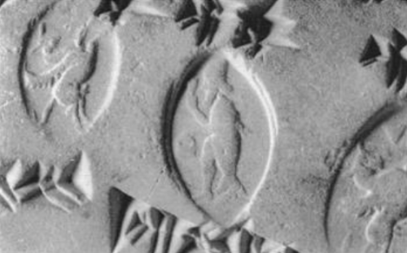
From Ronald Wallenfels, Apkallu-Sealings from Hellenistic Uruk, 1993.
Seal number 3. A fish-apkallu, a paradu-fish apkallu, depicted on a personal seal.
https://www.academia.edu/1368825/Apkallu-Sealings_from_Hellenistic_Uruk
It is interesting that a number of members of the Ekur-zakir clan actually owned apkallū-seals. So it is clear that the apkallū tradition was utilized by other scribal clans. See Ronald Wallenfels, “Apkallu-Sealings from Hellenistic Uruk,” Baghdader Mitteilungen 24 (1993), 309-24 and Tafeln 120-23.)
But are the scholars who created and copied this list really trying to manipulate the Seleucid court? Are they trying to insinuate that the traditional association of kings and scholars should continue under a non-native king?
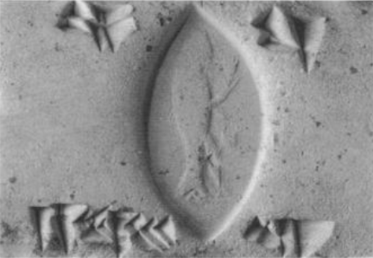
From Ronald Wallenfels, Apkallu-Sealings from Hellenistic Uruk, 1993.
Seal number 23. A fish-apkallu, a paradu-fish apkallu, depicted on a personal seal.
https://www.academia.edu/1368825/Apkallu-Sealings_from_Hellenistic_Uruk
Although this is possible, it is difficult to imagine how the scribes would ever have acquired an audience for their ideas. Moreover, the identification of the person in the last line of the text before the colophon indicates a negative answer to these questions and suggests a more subtle tactic from the scholars.
As is often the case, the culmination of an Akkadian list occurs in its final line where matters are summarized or its telos obtained. Thus, as van Dijk already recognized, the contemporary purpose of the ULKS probably rests precisely here.
(“Inschriftenfunde,” 45-46, 52. Concerning the reading of the last line, see also van Dijk’s later comments in his brief note “Die Tontafelfunde der Kampagne 1959/60,” Archiv für Orientforschung 20 (1963), 217.)
Unfortunately, the last line of our text is extremely frustrating. Unlike previous lines naming kings and scholars, all we have in this line is a break hiding one or two signs, a broken IŠ sign, and a name.
No one has yet been able to provide an acceptable restoration for the beginning of the line. The following interpretation, therefore, must remain tentative.”
Alan Lenzi, The Uruk List of Kings and Sages and Late Mesopotamian Scholarship, JANER 8.2, Brill, Leiden, 2008. pp. 161-3.
Share this:
- Twitter
- Facebook2
- Google
- Email
- Reddit

Like this:

Leave a comment
July 29, 2015
Lenzi: The Antediluvian Medical Tablet from Ashurbanipal’s Library (K.4023)
“As is well-known, antediluvian knowledge had special significance in Mesopotamia. (For other examples of antediluvian knowledge (though sometimes in a broken context), see the examples gathered by Lambert, “Catalogue of Texts and Authors,” 72 at the note on VI 15.)
The most important example of this fact for the purposes of this study comes from an oft cited colophon of a medical tablet from Ashurbanipal’s library, AMT 105,1 (K.4023), lines 21-25.
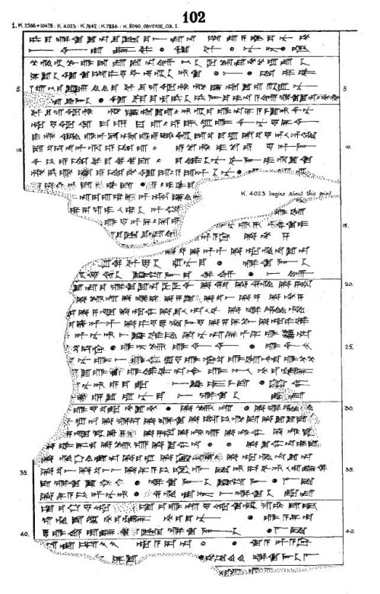
AM-102 ; No. #1 (K4023)
British Museum of London Tablet K.4023
COL. I
[Starting on Line 38] . . .
Root of caper which (is) on a grave, root of thorn (acacia) which (is) on a grave, right horn of an ox, left horn of a kid, seed of tamarisk, seed of laurel, Cannabis, seven drugs for a bandage against the Hand of a Ghost thou shalt bind on his temples.
FOOTNOTES:
[1] – The American Journal of Semitic Languages and Literatures, Vol. 54, No. 1/4 (Oct., 1937), pp. 12-40; Assyrian Prescriptions for the Head By R. Campbell Thompson
http://antiquecannabisbook.com/chap2B/Assyria/K4023.htm
This colophon shows not only the association of antediluvian sages and a human sage but also the “mythology of scribal succession” in action.
(For the original copy of the tablet, see R. Campbell Thompson, Assyrian Medical Texts (London: H. Milford / New York: Oxford University Press, 1923; reprinted, Osnabrück: Otto Zeller Verlag, 1983), 105,1 (=K.4023, col. iv, and thus probably from Nineveh).
I have cited the text according to Hermann Hunger, Babylonische und assyrische Kolophone, Alter Orient und Altes Testament 2 (Neukirchen-Vluyn: Neukirchener Verlag / Kevelaer: Verlag Butzon and Bercker, 1968), no. 533, with corrections from Yaakov Elman, “Authoritative Oral Tradition in Neo-Assyrian Scribal Circles,” Journal of the Ancient Near Eastern Society 7 (1975), 19-32, here 31.)
Salves (and) bandages: tested (and) checked, which are ready at hand, composed by the ancient sages from before the flood, which in Suruppak in the second year of Enlil-bani, king of Isin, Enlil-muballit, sage of Nippur, bequeathed.
Although the number of apkallū is unspecified in this text, the indication of plurality of sages and the antediluvian time frame strongly suggest an association with the seven sages known from traditions such as Bīt mēseri and the ULKS.
The fact that the tablet claims the apkallū composed these recipes bolsters the authority (by invoking these beings associated with Ea) and legitimacy (by asserting antiquity) of the recipes contained in the text.

This depiction of a fish-apkallū of the parādu-fish type guarded the entrance to the temple of Ninurta at Nimrud.
A fish’s head can be seen on the apkallu’s head, and its skin hangs down over the back of his body.
It is important to recall that the so-called Seven Sages of Sumeria were apkallū of this type.
Neo-Assyrian era, 865-860 BCE.
From the Temple of Ninurta, Nimrud (ancient Kalhu; Biblical Calah), northern Mesopotamia, Iraq. (The British Museum, London).
Osama Shukir Muhammed Amin FRCP (Glasg)
http://www.ancient.eu/image/2708/
But I do not think that is its primary purpose. The claim is not made in the context of a ritual; so it does not primarily function to create ritual power.
Rather, the claim occurs in a colophon, a label that communicates something about the tablet for other would-be readers/users of it. The invocation of the apkallū and a claim to antediluvian knowledge in a colophon intends therefore to affect the social situation in which the tablet is used.
In this case the colophon credentials a human being as the possessor of antediluvian knowledge (i.e., medical recipes). Revealed by primeval apkallū, mediated to the human sage Enlil-muballit, and transmitted, presumably, by means of various copyists to the present possessor, AMT 105,1 implies the same notion of succession as the ULKS.
A similar idea is probably attested in KAR 177, obv. iv 25-32, a text containing hemerologies, which reads:
Favorable days. According to the seven s[ages(?)].
Duplicate of a tablet from Sippar, Nippur, Babylon, Larsa, Ur, Uruk, and Eridu.
The scholars excerpted, selected, and gave it to Nazimuruttash, king of the world.
(The tablet is from Assur and presumably the NA period. The text and restorations follow W. G. Lambert, “Ancestors, Authors, and Canonicity,” Journal of Cuneiform Studies 11 (1957), 1-14, here 8.
Lambert also gives the remainder of the colophon, rev. iv 1-3 (8), which is of no interest in this context, and sets out von Soden’s readings in a follow-up note (“Ancestors, Authors, and Canonicity [JCS XI, 1-14]: Additions and Corrections,” Journal of Cuneiform Studies 11 [1957], 112).
It seemed highly unlikely to the editor (Lambert) that the seven cities named in the text represented the seven exemplars from which the scribe worked. In other words, it seems unlikely that the scribe was looking at seven different copies while writing his own tablet.
Instead, Lambert proposed that the seven cities represent a succession of exemplars. Each of the exemplars was written by one of the seven sages one after another thereby creating a line of succession for the present tablet that extends back into earliest times.
The claim of this colophon, therefore, is that the tablet of hemerologies over which the ummânū labored goes back to the apkallū and ultimately originated in Eridu, the home city of Ea.
This again demonstrates an example of the “mythology of scribal succession” and an implicit assertion of antediluvian knowledge.”
Alan Lenzi, The Uruk List of Kings and Sages and Late Mesopotamian Scholarship, JANER 8.2, Brill, Leiden, 2008. pp. 149-51.
Share this:
- Twitter
- Facebook1
- Google
- Email
- Reddit

Like this:

Leave a comment
July 17, 2015
On the Ummânu
“Such an association of the apkallu’s with kings of renown is singularly striking in view of the ancient near eastern motif that links a person of superior wisdom with a famous king.
In Egypt, we have the tradition — or fiction — of viziers who are credited with the authorship of “instructions” or “admonitions” (see J.A. Wilson, ANET 412 ff. and 432 n. 4, see also H. Brunner in Handbuch der Orientalistik I/2 p. 92 f.); for the Old Testament, references are conveniently collected by J. Lindblom, in Supplements to Vetus Testamentum 3, p. 129 f.
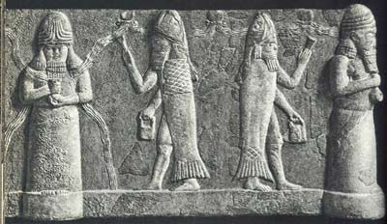
The god Ea at far left, wearing the horned headdress indicative of divinity, with water coursing from his shoulders. A fish-apkallū is in the iconic posture with right hand raised in blessing or exorcism, with the banduddu bucket in his left hand. The next apkallū wields an indistinct and as yet undefined angular object in his right hand, with the typical banduddu bucket in his left. The entity at far right, which appears to be wearing a horned tiara indicative of divinty, remains unidentified and undefined.
The most famous figure of such a wise man, whose story is the most wide spread, is Ahiqar, whose Mesopotamian origin has repeatedly been stated (for bibliography see Ginsberg in ANET 427), although no Babylonian prototype of the story as a whole is known.
However, there can be proven for Babylonia the existence of at least the theme that serves as a framework for Ahiqar’s sayings: this theme, the “disgrace and rehabilitation of a minister”, has been discussed, with a good comparative bibliography, by A.H. Krappe in JAOS 61 (1941) 280-84.
The story is included in the “bilingual proverbs” (latest publication with bibliography, by W.G. Lambert, Babylonian Wisdom Literature 239 ff.), where it comprises a section of fourteen lines (ii 50-63, op. cit., p. 241), the longest of the sayings which usually consist of only two to four lines, although there are some as much as eight lines long.

The umu-apkallū at far left has his right hand raised in the iconic gesture of purification and exorcism, but no mullilu cone appears to be present.
The banduddû bucket is present in the left hand. This umu-apkallū wears a horned tiara, indicative of divinity.
The next entity lacks wings, and so is probably not an umu-apkallū. The mace in the right hand could be an e’ru, as it is not yet clear precisely what e’ru means. I do not understand the object in his left hand. The mace could be an indicator of sovereignty, of kingship.
The next entity holds a bowl and the curved staff, known as the gamlu-curved staff. While this entity wears a headdress, it is not horned, and wings are absent, suggesting that it is human rather than umu-apkallū. This is probably a king, Museum notes suggest Ashurnasirpal.
The entity at far right wields a curved stick in his right hand, I am unsure how Wiggermann defines it, and I am completely stumped by the object in his left hand, which appears to be a ladle. The entity appears to be a priest, blessing an offering from the king in a bowl.
Overall, this frieze supports one theme of Erica Reiner’s article on the Seven Sages of Sumeria, which is that each king had his associated advisor in the form of an apkallū.
Since none of the previous translations does justice to the motif expressed in the relevant passage, I suggest the following (the short lines of the bilingual text disposed in two columns are here restored to their assumed full length):
- 50-51: “Their gods have returned to the ruin,
- 52-53: the clamor (of daily life) has filled (lit. entered) the deserted house (again);
- 54-55: (where) the ingrate is tenant, the wise man does not reach old age.
- 56-58: The wise vizier, whose wisdom his king (or his lord) has not heeded,
- 59-61: and any valuable (person) forgotten by his master,
- 62-63: when a need arises for him (i.e., for his wisdom), he will be reinstated.”
The second half of the “saying” has reference to the disgrace and rehabilitation of a wise vizier, and, unless the first three lines (ii. 50-55) should be taken as a separate saying (so last J. Pereman, The Book of Assyro-Babylonian Proverbs [in Hebrew], p. 58), the reference to the “ingrate” (raggu) would indicate that the other basic theme of the Ahiqar-story, that of the “ungrateful nephew” (see Krappe, loc. cit., p. 281), had already been fused in the Mesopotamian tradition, as in the Ahiqar-story, with that of the “disgrace and rehabilitation of a minister”.
The argument for the existence in Babylonia of a tradition linking wisdom to a high official (“vizier”) of the king can be strengthened by the philological evidence of the alternation of the terms apkallu and ummânu, which has been adduced in other contexts.

In the top register, Ummiamu, (a variant spelling of Reiner’s ummânu), human apkallū that are postdiluvian, tend to a sacred tree. In the lower register, antediluvian apkallū with avian heads tend to a sacred tree.
The cones and buckets in their hands are now understood to be standard devices used to sprinkle water. Called mullilu and banduddu, respectively, the water sprinkling ritual was intended to liberate sin, or as part of a rite of exorcism.
The usual acceptation of the latter is “master craftsman,” often referring to scribes, authors or copyists of literary texts. References to both have been collected by van Dijk, La Sagesse Suméro-Accadienne, p. 20 n. 56, and note that Adapa, besides his more common epithet apkallu, is also called ummânu . . .
Moreover, it has been shown the term ummânu serves not only as the designation of a learned man or craftsman, but also refers, although in late texts, to a high official . . . In our connection most relevant is the mention of the ummânu beside the king in the Synchronistic King List (see simply Oppenheim in ANET 272 ff.), and the passage from the Fürstenspiegel (see now Lambert, BWL 112:5): šarru . . . ana UM.ME A la iqūl “if the king does not heed the vizier (or wise man).”
Note in the same text . . . is most likely to be read apkallišu.”
Erica Reiner, “The Etiological Myth of the “Seven Sages,” Orientalia, v. 30, No. 1, 1961, pp. 7-9.
Share this:
- Twitter
- Facebook3
- Google
- Email
- Reddit

Like this:

Leave a comment
June 22, 2015
Editorial Note on the Apkallu and the Roadmap Ahead
I am breaking the narrative stream to speak directly to the process emerging from our reading on the apkallū, the antediluvian and postdiluvian sages of ancient Mesopotamia.
If you are reading along over my shoulder, you noticed that we digressed from Martin Lang, “Mesopotamian Early History and the Flood Story,” in a post titled On the Date of the Flood.
Martin Lang wrote:
“Berossos’ own knowledge of primordial kings probably goes back to sources that were available in Hellenistic times. The Sumerian King List itself was still known in the Seleucid era, or rather versions of king lists that echo, structurally and stylistically, their ancient forerunners from the early second millennium.
In matching up the primordial kings with the seven sages, the apkallū, Berossos once again works in the vein of contemporary scholars, who demonstrably constructed lists with kings and apkallū in order to advertise their own importance, and the primordial roots of their knowledge, as Alan Lenzi has recently shown.”
I updated that post to include a link to Alan Lenzi, “The Uruk List of Kings and Sages and Late Mesopotamian Scholarship,” JANER 8.2, 2008, which is serialized and linked in posts below.
I also changed the link to the Sumerian King List to point to the beautiful 1939 edition by Thorkild Jacobsen generously published by the University of Chicago Press, available for free download off the web.
We then dipped into Anne Draffkorn Kilmer, “The Mesopotamian Counterparts of the Biblical Nephilim,” in Francis I. Andersen, et al, eds., Perspectives on Language and Text: Essays and Poems in Honor of Francis I. Andersen’s Sixtieth Birthday, 1985, in a post titled On the Apkallū.
This is where I drilled in hard on the apkallū, incorporating bas reliefs and figurines held at the Louvre and the British Museum. Out of numerous posts addressing the apkallū, this one is well-illustrated, and lushly hyperlinked.
Moreover, Anne Kilmer synthesized the supporting research on the apkallū at the time of writing very effectively, so if you are overwhelmed by the other articles, just read this one. It goes without saying that you should not be intimidated by this academic literature. I have made it as readable and accessible as I can.
Yes, there is a lot of it. As I excavate the academic literature on the apkallū the hard way, mining references from footnote after footnote, I get a sense of what it might be like, to be an academic Assyriologist rather than an autodidact.
I do not include everything that I find. I assess and include just those pieces which accrue gravitas in that greater academic community. If you see glaring omissions, please let me know. This note is shaping up to be an academic survey of the literature on the apkallū, and it may save others treading these same paths some time.
Fair warning: our continuing digression into the apkallu will be deep.
As I complete serialization of source texts, I will include links to the posts beneath their citation below. These sources are sorted by date, so we can track the evolution of academic thinking on the apkallū. Our digression includes excerpts from:
- Erica Reiner, “The Etiological Myth of the “Seven Sages,” Orientalia, v. 30, No. 1, 1961, pp. 1-11. Posted as:
  - Erica Reiner on the Etiological Myth of the “Seven Sages.”
  - Each King had his Apkallū.
  - On the Ummânu.
  - Why No Canonical Literature Regarding the Apkallū?
- Anthony Green, “Neo-Assyrian Apotropaic Figures,” Iraq, Vol. 45, 1983.
  - From Anthony Green, Neo-Assyrian Apotropaic Figures, 1983.
  - Figurines Excavated from the Burnt Palace and Fort Shalmanesar.
  - Green Identifies the Lahmu and the Ugallu.
  - Green Defines Numerous Figures.
- Anne Draffkorn Kilmer, “The Mesopotamian Counterparts of the Biblical Nephilim,” in Francis I. Andersen, Edgar W. Conrad, & Edward G. Newing, eds., Perspectives on Language and Text: Essays and Poems in Honor of Francis I. Andersen’s Sixtieth Birthday, 1985, posted as:
  - On the Apkallu.
- H.S. Kvanvig, Roots of Apocalyptic: The Mesopotamian Background of the Enoch Figure and the Son of Man, WMANT 61, 1988.
- E. Noort, “The Stories of the Great Flood: Notes on Genesis 6:5-9:17 in its Context of the Ancient Near East,” in F. Garcia Martinez and G.P. Luttikhuizen, eds., Interpretations of the Flood, 1988.
- Jean Bottéro, Mesopotamia: Writing, Reasoning, and the Gods, Zainab Bahrani and Marc Van De Mieroop (translators); Chicago: University of Chicago Press, 1992.
- F.A.M. Wiggermann, Mesopotamian Protective Spirits: The Ritual Texts, Brill, 1992. Posted as:
  - Lahmu, “The Hairy One,” is Not Apkallu.
  - Mesopotamian Apotropaic Gods and Monsters.
  - Apkallu Details (Excerpt from Wiggermann).
  - Statues in Private Rooms, the apkallū, “Sages.”
  - On the Banduddū, or “Bucket.”
  - On the Mullilu, the “cleaner,” the Purification Instrument of the Apkallū Exorcist.
  - Things that Apkallū Hold.
  - On the Names of the Ūmu-Apkallū.
  - Bird-Apkallū, Characterized as Griffin Demons.
  - On the Fish-Apkallū.
  - Wiggermann Defines the Lamassu.
- F.A.M. Wiggermann, “Mischwesen A,” Reallexikon der Assyriologie und Vorderasiatischen Archäologie (RlA) 8, Berlin, 1993-7.
- Anthony Green, “Mischwesen B,” Reallexikon der Assyriologie und Vorderasiatischen Archäologie (RlA) 8, Berlin, 1993-7.
- Rykele Borger, “The Incantation Series Bīt Mēseri and Enoch’s Ascension to Heaven,” in I Studied Inscriptions from Before the Flood: Ancient Near Eastern, Literary, and Linguistic Approaches to Genesis 1-11 (ed. R.S. Hess and D.T. Tsumura; Sources for Biblical and Theological Study 4, Winona Lake: Eisenbrauns, 1994), pp. 224-33.
- Schlomo Izre’el, Adapa and the South Wind: Language Has the Power of Life and Death, Eisenbrauns, 2001.
  - Izre’el: Origins of the Adapa Myth.
  - Izre’el: The Tale of the Adapa Myth.
  - Izre’el: Listing the Fragments.
  - Izre’el: Adapa and the South Wind as Mythos.
- Carolyn Nakamura, “Dedicating Magic: Neo-Assyrian Apotropaic Figurines and the Protection of Aššur,” World Archeology, 2004.
- Ronald Hendel, “The Nephilim Were on the Earth: Genesis 6:1-4 and its Ancient Near Eastern Context,” in Christoph Auffarth and Loren T. Stuckenbruck, eds., The Fall of the Angels, Brill, 2004, posted as:
  - The Children of El in Ancient Ugarit
  - Asherah, Astarte, Anat, Athirat in Ancient Ugarit
  - Correspondences Between Apkallu and the Nephilim
  - Flood Traditions
  - The Sexual Mingling of Gods and Humans
  - Sex, Evil, and the Fall.
- Carolyn Nakamura, “Mastering matters: magical sense and apotropaic figurine worlds of Neo-Assyria,” Archaeologies of materiality (2005): 18-45.
  - Carolyn Nakamura on the Figurines.
  - Nakamura: Rimbaud’s Derangement of All the Senses, Magic, and Archeology.
  - Nakamura: More on Magic and Archeology.
  - Nakamura: Magic Produces Wonder.
  - Nakamura: Magic as Mimesis in Mesopotamia.
  - Nakamura: Magic’s Perception and Performance.
  - Nakamura: Clay Pit Ritual.
  - Nakamura: The Common Terrain Shared by Myth and Iconography.
  - Nakamura: An Idiom of Protection Arises in the Material Enactment of Memory.
  - Nakamura: Humans Make Up the gods Who Make Them.
  - Nakamura: The Figurines as Magical Objects.
  - Nakamura: The āšipu was Master of the Figurines.
  - Nakamura: Magic Enchants Us with the Possible Made Real.
- Alan Lenzi, “The Uruk List of Kings and Sages and Late Mesopotamian Scholarship,” JANER 8.2, 2008.
  - Lenzi: The Uruk List of Kings and Sages.
  - Lenzi: The Mythology of Scribal Succession.
  - Lenzi: On the apkallū-ummânū Association.
  - Lenzi: Human Apkallū are a Later Inclusion.
  - Lenzi: A Fault Line Where Legend and History Collides.
  - Lenzi: The Apkallū and the Ummânū May Be Artificially Related.
  - Lenzi: The Antediluvian Medical Tablet from Ashurbanipal’s Library (K.4023).
  - Lenzi: The ummânū Were The Scribal Heirs of the Antediluvian Sages.
  - Lenzi: Strabo, Pausanias and Pliny All Have Agendas.
  - Lenzi: On the Restoration of the Temples.
  - Lenzi: On Nikarchos and Kephalon.
  - Lenzi: The Exaltation of the god Anu.
  - Lenzi: More on the Exaltation of the Anu Cult.
  - Lenzi: Authority Rooted in Divinity.
  - Lenzi: The Uruk List of Kings and Sages Renewed the Anu Cult.
- David P. Melvin, “Divine Mediation and the Rise of Civilization in Mesopotamian Literature and in Genesis 1-11,” The Journal of Hebrew Scriptures, v. 10, art. 17, 2010.
  - Melvin: Origins of Human Civilization–Divine Mediation or Human Endeavor?
  - Melvin: Divine or Semi-Divine Intermediaries.
  - Melvin: On the Role of Divine Counsel.
  - Melvin: Human Civilization is a Gift of the gods.
  - Melvin: Who Built the First City? Cain? Enoch? Chouser? Or Nimrod?
  - Melvin: On the Tower of Babel.
  - Melvin: Divine Instruction Reappears in 1 Enoch.
  - Melvin: Divine Knowledge was Sexual Knowledge.
  - Melvin: Divine Knowledge is Transcendent.
  - Melvin: Human Knowledge is Sinful.
- Trevor Curnow, Wisdom in the Ancient World, Bloomsbury, 2010.
  - Curnow: Boundaries of Legend and History.
  - Curnow: Ziusudra Divides Invented Myth from Mythologized Fact.
  - Curnow: Atrahasis is More Historical Than Noah.
- Stephanie Dalley, “Apkallu,” Iconography of Deities and Demons in the Ancient Near East (IDD), Swiss National Science Foundation, University of Zurich, 2011 (text updated 2011 and illustrations updated 2007).
  - Dalley: Apkallu, IDD 2011.
  - Dalley: Apkallu-2, IDD 2011.
  - Dalley: Apkallu-3, IDD 2011.
  - Dalley: Apkallu-4, IDD 2011.
  - Dalley: Apkallu-5, IDD 2011.
  - Dalley: Apkallu-6, IDD 2011.
  - Dalley: Apkallu-7, IDD 2011.
- Helge Kvanvig, Primeval History: Babylonian, Biblical, and Enochic: An Intertextual Reading, Brill, 2011.
  - Kvanvig: The Lists of the Seven Apkallus.
  - Kvanvig: The Apkallu List From Bīt Mēseri.
  - Kvanvig: Discrepancies Between the Lists.
  - Kvanvig: Introducing Ahiqar.
  - Kvanvig: Berossos and Primeval History.
  - Kvanvig: Introducing the Apkallu Odakon.
  - Kvanvig: The Apkallus Had a Cosmic Function.
  - Kvanvig: Bīt Mēseri and the Adapa Myth.
  - Kvanvig: The Adapa Myth Symbolizes the Initiation of Humanity into Civilization.
  - Kvanvig: Adapa Breaks the Wing of the South Wind.
  - Kvanvig: On the Destiny of Adapa.
  - Kvanvig: The Apkallu are on the Borderline Between the Human and the Divine.
  - Kvanvig: Human Knowledge is Dangerous to the Cosmic Order.
  - Kvanvig: Limitations of Human Wisdom and the Loss of Eternal Life.
  - Kvanvig: The Apkallus as Protective Spirits.
  - Kvanvig: The Bīt Mēseri Ritual.
  - Kvanvig: On Sēp lemutti, Averting Evil.
  - Kvanvig: The ilū mušīti Are the Stars of the Night.
  - Kvanvig: The Maklû Ritual Against Witchcraft.
  - Kvanvig: The mīs pî and pīt pî Rituals of Mouth Washing and Mouth Opening.
  - Kvanvig: Aššurbanipal Studied Inscriptions on Stone From Before the Flood.
  - Kvanvig: Surpassing the Wisdom of the Abyss–Or Not.
  - Kvanvig: Five Specialties of Sages Communicating with the Divine.
  - Kvanvig: The Sacred Tree.
  - Kvanvig: The apkallus as Watchers and Guardians.
  - Kvanvig: Transmission of Antediluvian Revelation.
  - Kvanvig: Antediluvian Scribes of the gods.
  - Kvanvig: Initiation is a Restriction of Marduk.
  - Kvanvig: Divine Origin of Antediluvian Texts.
  - Kvanvig: On the Correspondences Between Antediluvian Myths.
  - Kvanvig: At the Brink of Legendary Time and Historical Time.
  - Kvanvig: Earthly Counterparts of the Divine Watchers.
  - Kvanvig: Dates the apkallu to the Beginning of the 1st Millennium BCE.
- Gebhard J. Selz, “Of Heroes and Sages–Considerations of the Early Mesopotamian Background of Some Enochic Traditions,” in Armin Lange, et al, The Dead Sea Scrolls in Context, v. 2, Brill, 2011.
  - Selz: Enoch Derives from 3d Millennium BCE Mesopotamia.
  - Selz: On Giants.
  - Selz: An Excerpt from the Book of Giants.
  - Selz: Enūma Anu Enlil and MUL.APIN.
  - Selz: On the Astronomical Diaries of Babylon.
  - Selz: The Debate Over Mesopotamian Influence on Jewish Pre-History is 2000 Years Old.
  - Selz: No Connection Between the Biblical Patriarchs and the Babylonian Antediluvian Kings.
  - Selz: Tracking Gilgamesh Throughout History and Literature.
  - Selz: Patriarchs and Sages.
  - Selz: Connects the Apkallu with the Fallen Angels.
  - Selz: On Sacred Marriage.
  - Selz: Victory Steles, Dreams and the Erra Epic.
  - Selz: The Dream of Gudea.
  - Selz: Plant of Life or Plant of Birth in the Etana Legend?
- Constance Ellen Gane, Composite Beings in Neo-Babylonian Art, University of California, 2012.
  - Gane: Composite Beings in Neo-Babylonian Art.
  - Gane: A Study of Mischwesen in the Neo-Babylonian Period.
  - Gane: Neo-Babylonian Monsters, Demons & Dragons From a Narrow Slice of Time & Space.
  - Gane: Review of the Literature on Monsters, Demons and gods.
  - Gane: Applying Black’s Theory of Metaphor.
After we complete our deep dive into the apkallu, we will return to the Sumerian King List, then resume with Berossos. This is the roadmap ahead.
Editorial note: In some cases citations above which are not followed by links in the bulleted list are internet dry holes, no digital versions are available. In other cases, links are to Google Books editions, which often limit visible pages. Google’s intent is to sell electronic versions of the texts that they scan.
Under these circumstances, I end up rekeying entire articles, at ruinous waste of time. If you have a moment, please send a sweet nastygram to Google asking them to post free and complete eBooks as they continue their vast project to digitize the entirety of human knowledge.
In other cases, I simply have not yet reviewed the articles and posted them. If you are following this project, you see that I post updates nearly every day. Stay tuned.
My purpose in publishing Samizdat is to highlight excerpts from the great books, mining synchronicities from legends and myths. As I point out in the About page, the Deluge was an historical event for the ancient Sumerians.
I now need to update that page, incorporating the research that we have already completed on the Sumerian King List, setting up a future digression into the concept of the Great Year, which Berossos associated with traditions of a Conflagration and the Deluge.
If you wondered where we were going, I wrote this for you.
Updated 20 November 2015, 23:39 hrs.
Share this:
- Twitter
- Facebook6
- Google
- Email
- Reddit

Like this:

Leave a comment
June 19, 2015
On the Apkallu
“During the course of the years studying and teaching the Primeval History as recorded in the literary texts of ancient Mesopotamia, this writer has been struck by certain similarities between the Akkadian apkallu (Sumerian algal / NUN.ME / EN.ME), creatures of the god Ea, the “sages of old,” and the biblical nēpīlîm of Genesis 6 who are introduced just before the flood account.
In the Mesopotamian king and sage lists, the apkallu occur in the pre-flood era, and in some texts for a limited time after the flood. In general, however, the pre-flood sages are called apkallu and their traditional number is seven, while the post-flood sages are called the ummiānu.

Apkallu portrayed with Ea, at far left, with water coursing from his shoulders.
The apkallu are semi-divine beings who may be depicted as mixed beings, as priests wearing fish hoods, or who may, like Adapa, be called a son of Ea. Moreover, humans and apkallu could presumably mate since we have the description of the four post-flood apkallu as “of human descent,” the fourth being only “two-thirds apkallu” as opposed to pre-flood pure apkallu and subsequent human sages (ummiānu).
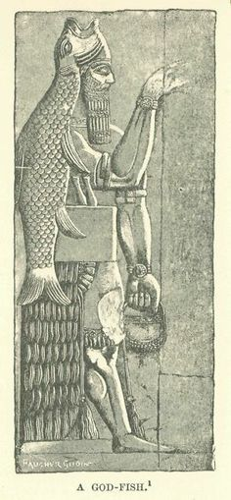
A depiction of the apkallu, Adapa, or Oannes.
The short mythological “episode” in Genesis 6:1-4 tells us only that after the population increased, the nēpīlîm appeared on the earth after divine beings (sons of elohim) had mated with the daughters of men. The following verse (v. 5) states that Yahweh saw that men’s wickedness was great.
It can be assumed from this brief account that the nēpīlîm were the offspring of those divine fathers and human mothers, and that it was the nēpīlîm who somehow exemplified wicked mankind in general. Let us now turn to the Mesopotamian apkallu tales and lists to see how their behavior, as well as their parentage, may have some features in common with the nēpīlîm.
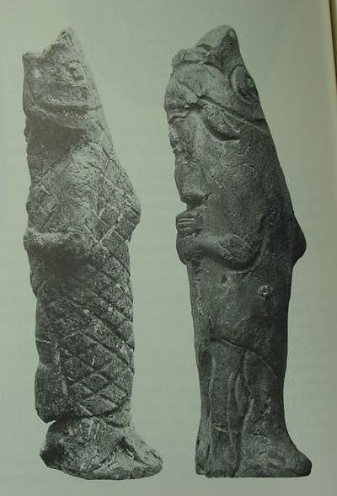
Antediluvian apkallu portrayed as fish-men, such mixed-species creatures were the teachers of men.
The most celebrated apkallu was Adapa, identified as a son of Ea. As we are told in the best known and best preserved myth about him, he executed an act of hubris by breaking the wing of the south wind; the end result, for him, of that wicked act was that he was denied immortality.
He is probably to be equated with the last antediluvian apkallu who was reported to have ascended to heaven. As we know from the late lists of sages, several other apkallu at the time of the flood or right after it also committed daring or wicked acts (the list that follows is abbreviated with respect to details and is conflated from the pertinent texts):
Antediluvian apkallu
- Uanna — Who completed the plans of heaven and earth
- Uannedugga — Who was endowed with comprehensive intelligence
- Enmedugga — Who was allowed a good fate
- Enmegaluamma — Who was born in a house
- Enmebulugga — Who grew up on pasture land
- Anenlilda — The exorcist of Eridu
- Utuabzu (Utuabba) — Who ascended to heaven
- [Total of] seven brilliant purādu fish . . . born in the river, who direct the plans of heaven and earth.
(Editorial note, source: Bit Mēseri III, 14’=27′)
Postdiluvian apkallu
- (both Adapa and Nunpiriggaldim are associated with Enmerkir)
- Nungalpiriggaldim — Who brought down Ishtar from heaven and who made the harp decorated with bronze and lapis*
- Piriggalnungal — Who angered Adad*
- Piriggalabsu — Who angered Ea*
- Lu-Nanna (2/3d apkallu) — Who drove the dragon from Ishtar’s temple*
- *[Total of] four of human descent whom (pl.) Ea endowed with comprehensive intelligence.
(Editorial note, also see source: Helge Kvanvig, Traditions of the Apkallus, Primeval History: Babylonian, Biblical and Enochic: An Intertextual Reading, Brill, 2011.)
Thus we see that the traditions about the superhuman apkallu contained stories, most of them lost to us, about their famous and infamous deeds. But it is the latter ones, from Adapa to Piriggalabzu (sic), around whom the obvious misbehavior clusters.
It is of further interest to note that the pivotal role of the nēpīlîm passage in Genesis 6 occurs together with the theme of increased population growth on which Genesis 6 opens. If we compare the Mesopotamian material, we see a similar position in the storytelling for the importance of population increase and concomitant wickedness as a factor leading to the flood.
The Mesopotamian sages were endowed with wisdom and special powers because they were created by the god Ea and associated with the deep (as fish-men, etc.). Because of their powers they were capable of acts that could impress or offend the gods, that could cause beneficial or harmful natural phenomena.
It is the negative side of them that seems to be involved in the period just before and after the flood in the sage lists. A similar theme runs through the Atrahasis Epic; there, at each attempt of the gods to decrease men’s numbers by means of drought, etc., Ea instructs his son (?) Atrahasis, the Extra Wise and thus a sage figure in his own right but also to be equated with the king of Shuruppak, how to outwit the gods and overcome hardship.
Thus each god whose cult is neglected and deprived of offerings, as a result of those instructions, was sure to be angered. Their collective anger at such acts and their disgust at humanity’s increase and bad condition led to the joint decision to send the flood.
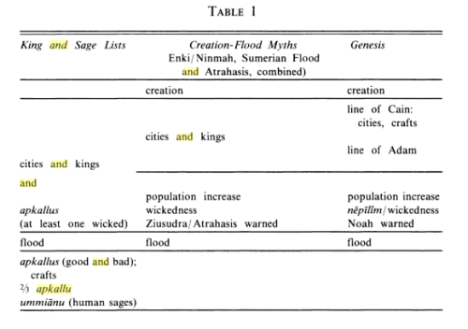
Whereas the Mesopotamian myth and list traditions single out and keep distinct the sages and king-heroes, Genesis 6:4 speaks only of the “heroes of old, men of renown” and equates them with the nēpīlîm. In fact, it is possible that this verse intended to equate both the lines of Adam and Cain with the nēpīlîm. If so, the reintroduction of Noah four verses later would complete the line of thinking, since Noah was one of the heroes of old.
Yet the line of Cain (the Smith), juxtaposed as it is with the line of Adam, seems to operate in a manner similar to the Mesopotamian traditional list of the line of sages juxtaposed with the line of kings, as others have argued.
Like the apkallu who built the early cities and those who brought the civilized arts to men, the line of Cain performed the same service (or dis-service, in the biblical view). As to v 3 concerning man’s shortened lifespan, it may have its counterpart in the post-flood renegotiations of the terms for man’s continued existence as described in the Atrahasis Epic.
There, the fixing of a term of life for mortals was probably contained in the fragmentary section about controlling population growth. In the Sumerian King List it is only after King Gilgamesh (who was 1/3d divine) that rulers begin to have more normal longevity (beginning with the 126 year reign of his successor).
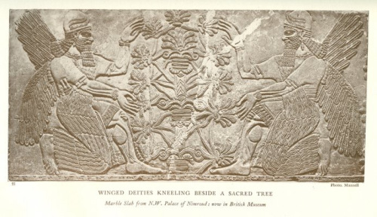
Postdiluvian advisors to kings who were men, the ummianu, were the successors of the antediluvian mixed-species Apkallu who were portrayed as fish-men. In this frieze now held in the British Museum they tend to a sacred tree. The antediluvian Apkallu were the so-called seven sages of Sumeria.
One other cuneiform text can be mentioned in which the sages may be associated with wicked acts, viz. The Epic of Erra (alternative full text of the Epic from Foster’s B is available). There the sages (called ummiānu) seem to be guilty by implication since we are told that they were dispatched for good to the apsu at the time of the flood and may have been deprived access to the mes-tree, “the flesh of the gods,” which provided them with the special material to make divine and kingly statues (as well as knowledge, skill and longevity?), but which was hidden from them (and all future mortals) forever when Marduk cast it into the deep.
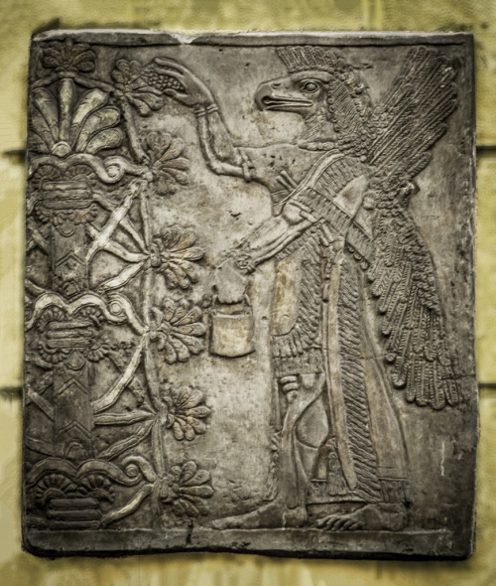
In Neo-Assyrian art these bird-headed “genies,” as they are often described, are now known to be apkallu, mixed-feature creatures created by the god Ea. They traditionally served as advisors to kings. They are often depicted in association with sacred trees.
https://www.flickr.com/photos/lanpernas2/8606000868/
If the flood is the same Abubu perhaps the mes-tree (see footnote 11 below) may be compared with the plant (of life) whose hidden location in the deep Utnapishtim revealed to Gilgamesh. If so, it leads us to suspect a further connection between the Mesopotamian mythological trees and plants and the tree(s) in Eden to which another sage figure, Adam, had once had access.
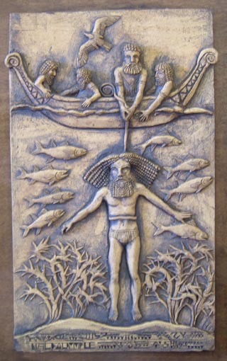
A modern depiction of Gilgamesh harvesting the Plant of Life from the ocean floor, guided by Utnapishtim, the deified survivor of the Deluge.
http://www.mediahex.com/Utnapishtim
In short, we may be able to look to the Mesopotamian sage traditions for the mythological background of Genesis 6:1-4. While the ties between the apkallu and the nēpīlîm are hardly ties that bind, there are enough points of comparison—superhuman / semi-divine beings, acts of daring / hubris, acts that anger divinity, association with wickedness in men, their predominantly pre-flood existence—to encourage our consideration.
The Mischwesen sages seem at least to be closer to the nēpīlîm topically than the theogony materials concerning the generations of the gods. It is hoped that the circumstantial evidence for a remote connection between the apkallu and the nēpīlîm is strong enough to have been worth trying the case.”
(Footnote 11: Now that the bird-faced winged genies of Assyrian Palace art may be identified as apkallu (see Anthony Green, “Neo-Assyrian Apotropaic Figures,” Iraq 45 (1983), pp. 87-96) the close association of apkallu with special trees is clear.)
(For other mixed-beings, creatures of Ea, note F. Köcher, “Der babylonische Göttertypentext,” Mitteilungen des Instituts für Orientforschung 1 (1953), pp. 72, 74, 78, 80.)
Anne Draffkorn Kilmer, “The Mesopotamian Counterparts of the Biblical Nephilim,” in Francis I. Andersen, Edgar W. Conrad, & Edward G. Newing, eds., Perspectives on Language and Text: Essays and Poems in Honor of Francis I. Andersen’s Sixtieth Birthday, 1985, pp. 39-43.
Share this:
- Twitter
- Facebook10
- Google
- Email
- Reddit

Like this:

Leave a comment
June 17, 2015
On the Date of The Flood
“I now turn to Berossos’ account of the Flood as the central narrative of book 2. The extant fragments contain the following elements:
- – Kronos reveals the destruction of mankind in a dream
- – Xisouthros is told he must bury the tablets in Sippar
- – He must build a boat and embark together with family, friends, and animals
- – The coming and receding of the deluge (mentioned in only one sentence)
- – Bird scene
- – Disembarking
- – Worship and ritual offering
- – Disappearance of Xisouthros, who will henceforth live with the gods
- – Xisouthros’ friends and relatives are told (not by Kronos, but a ‘voice’) to go to Sippar and dig up the tablets, and to hand them over to mankind.
- – Landing place in Armenia, in the Korduaian mountains. The remains of the ark are still there, and people scrape off bitumen for magic purposes.
In Mesopotamian accounts of the deluge the Flood marks a break between a mythic prehistory and a history closer to the world as it is today. According to Manfried Dietrich, many mythical texts from Mesopotamia reflect this view of history, whereby an embryonic phase in the development of the world (‘embryonaler Status’) is followed by what he calls the ‘Jetzt-Zeit’, i.e. the present time.
The extant fragments of Berossos follow the same overall scheme. For Berossos too, the time before the Flood is a period of revelation, when the basis for all later knowledge was laid. Writings originating in this period would accordingly have a special authority and ‘the history which follows is the time when this revelation is transmitted and unfolded.’
Berossos was not the first to connect an antediluvian king list with the Flood story: already the Sumerian version of the Flood story mentions five primeval cities known also from copies of the Sumerian King List.
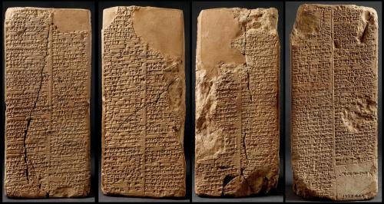
Among all the extant exemplars of the Sumerian King List, the Weld-Blundell prism in the Ashmolean Museum cuneiform collection represents the most extensive version as well as the most complete copy of the King List.
In this depiction, all four sides of the Sumerian King List prism are portrayed.
It lists rulers from the antediluvian dynasties to Suen-magir, the fourteenth ruler of the Isin dynasty (ca. 1763–1753 B.C.).
The prism contains four sides with two columns on each side. Perforated, the prism must originally have a wooden spindle going through its centre so that it might be rotated and read on all four sides.
http://cdli.ox.ac.uk/wiki/doku.php?id=the_sumerian_king_list_sklid=the_sumerian_king_list_skl
Berossos’ own knowledge of primordial kings probably goes back to sources that were available in Hellenistic times. The Sumerian King List itself was still known in the Seleucid era, or rather versions of king lists that echo, structurally and stylistically, their ancient forerunners from the early second millenium.
In matching up the primordial kings with the seven sages, the apkallu, Berossos once again works in the vein of contemporary scholars, who demonstrably constructed lists with kings and apkallu in order to advertise their own importance, and the primordial roots of their knowledge, as Alan Lenzi has recently shown (Editorial note: this link is to Alan Lenzi, “The Uruk List of Kings and Sages and Late Mesopotamian Scholarship,” JANER 8.2, 2008, which will be serialized in its own posts shortly).
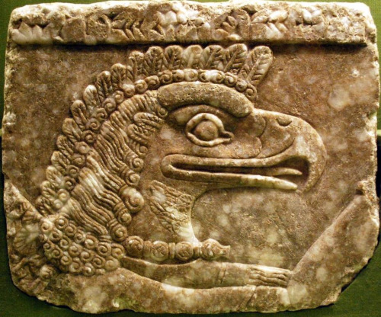
Detail, apkallu head, from a frieze in Nimrud.
http://non-aliencreatures.wikia.com/wiki/Apkallu
Yet, Berossos does not merely translate ancient documents, but rather selects and reframes what he finds, thus constructing his own version of the past. For a start, he locates the beginnings of kingship in Babylon and not in Eridu as the first city of Mesopotamian tradition.
Moreover, he reckons the overall duration of pre-flood history at 432,000 years (120 saroi = 120 x 3600 years), a sum that reflects the sexagesimal counting system of ancient Mesopotamia but which, as far as we know, is unique in Mesoptamian tradition.
432,000, however, is no arbitrary accumulation of individual reigns, but rather represents an astronomical ‘great year’, or an exact fraction of it. A great year is the period of time it takes for all heavenly bodies to return to their original place in the sky.
Berossos evidently had at least some astronomical knowledge, and moreover was keen to display his knowledge. Indeed, another peculiarity of Babyloniaca 2, beside the exorbitant reigns of the pre-flood kings, is Berossos’ unusual and very specific reference to a date for the Flood:
Kronos stood over him in his sleep and said that on the 15th of the month of Daisios mankind would be destroyed by a flood.
The Armenian version (F4a) supplies some explanatory glosses inserted at a later stage (in italics):
He says that Kronos, whom they call the father of Aramazd and others call Time, revealed to him in his sleep that on the 15th of the month of De(s)ios, which is Mareri, mankind was to be destroyed by the Flood.
There is no mention of a specific date in cuneiform texts about the Flood, yet Berossos puts it on ‘the fifteenth of the month Daisios’. According to the Macedonian calendar introduced by the Seleucids, Daisios is the 8th month of the year, and comes in spring (April/May, Babylonian Ayyaru).
Perhaps Berossos inserted a Macedonian dating in order to make it more relevant to his readers who were familiar with Greek Flood narratives. The choice of date may not be entirely accidental, as the Tigris and the Euphrates burst their banks in spring.
However, extant cuneiform sources link the deluge with rains and a cosmic storm rather than natural inundations, and we may have to look elsewhere for an explanation.”
Martin Lang, “Book Two: Mesopotamian Early History and the Flood Story,” from Johannes Haubold, Giovanni B. Lanfranchi, Robert Rollinger, John Steele (eds.), The World of Berossos, Proceedings of the 4th International Colloquium on the Ancient Near East Between Classical and Ancient Oriental Traditions, Harrassowitz Verlag, Wiesbaden, 2013, pp. 49-51.

